Time-Triggered Communication
# Source: AI Source: Provided by: [Data Path: Persons Table -> ID Column: 1, Name_En Column: Motasem Essam] -> From: [ChatGPT] on [1/21/2026]
Time-Triggered Communication is a type of Real-Time Communication used in systems where messages must be delivered at precise, predetermined times. It is widely used in safety-critical real-time systems like automotive, avionics, and industrial automation.

Definition
# Source: AI Source: Provided by: [Data Path: Persons Table -> ID Column: 1, Name_En Column: Motasem Essam] -> From: [ChatGPT] on [1/21/2026]
Time-triggered communication is a method in which:
- Messages are transmitted at fixed, pre-scheduled time intervals.
- Communication is deterministic – timing of message delivery is predictable.
- Often implemented using synchronized clocks across all nodes in the system.

Key Features
# Source: AI Source: Provided by: [Data Path: Persons Table -> ID Column: 1, Name_En Column: Motasem Essam] -> From: [ChatGPT] on [1/21/2026]
- Deterministic Timing
  - Every message has a fixed transmission time → no uncertainty.
- Periodic Communication
  - Messages are sent at regular intervals, defined in the schedule.
- Predictability and Safety
  - Ideal for hard real-time systems where missing a deadline could be catastrophic.
- Synchronization Required
  - Nodes must have synchronized clocks to follow the communication schedule.

Example
# Source: AI Source: Provided by: [Data Path: Persons Table -> ID Column: 1, Name_En Column: Motasem Essam] -> From: [ChatGPT] on [1/21/2026]
In an automotive system:
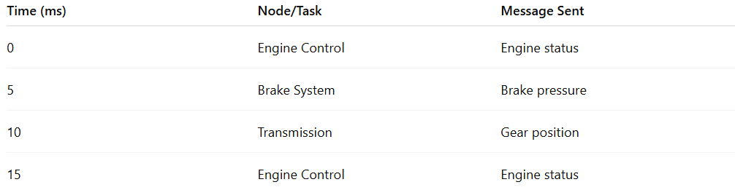
Time (ms) | Node/Task | Message Sent
0 | Engine Control | Engine status
5 | Brake System | Brake pressure
10 | Transmission | Gear position
15 | Engine Control | Engine status
- Each task sends messages at predetermined time slots.
- Timing is guaranteed, so controllers can act predictably.

Advantages
- Highly predictable and deterministic
- Suitable for safety-critical and hard real-time systems
- Eliminates contention for communication resources
Disadvantages
- Inflexible – hard to add new messages dynamically
- Requires precise clock synchronization
- Overhead in maintaining static schedules

Applications
- Automotive networks (e.g., CAN Time-Triggered protocol)
- Avionics systems (e.g., ARINC 653)
- Industrial automation and robotics

If you want, I can also explain the 2nd type: Event-Triggered Communication and compare it with Time-Triggered, which helps you understand real-time communication design choices.
Do you want me to do that?

